## Zuma (Game) - Giant Bomb

##### ***ABOUT THIS GAME:***

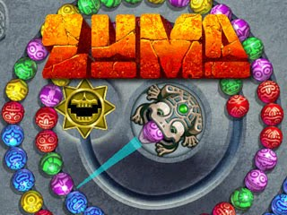

**Zuma is a 2003 tile-matching puzzle video game developed by Oberon Media and published by PopCap Games. It was released for a number of platforms, including PDAs, mobile phones, and the iPod.**